Graphing Inequalities
In this internal we are not only graphing lines that are equal, but we are wanting to graph areas that are more or less than a line to find a ‘feasible region’. This is an area where all of the inequalities hold true. The first one has been done for you.

Question 1  4x + 3y ≤ 120  7x + 8y ≤ 280  x ≥ 5  y ≥ 10 | 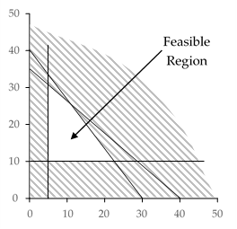
Question 2
10x + 9y ≤ 450
3x + 8y ≤ 240
x ≥ 11
y ≥ 18

Question 3
5x + 3y ≤ 300
7x + 9y ≤ 630
x ≥ 10
y ≥ 8

Question 4
16x + 15y ≤ 1200
7x + 19y ≤ 665
x ≥ 20
y ≥ 5

Question 5
11x + 14y ≤ 770
9x + 20y ≤ 900
x ≥ 16
y ≥ 20

Question 6
17x + 8y ≤ 680
9x + 13y ≤ 585
x ≥ 7
y ≥ 17

Question 7
13x + 5y ≤ 325
8x + 15y ≤ 600
x ≥ 10
y ≥ 9

Question 8
17x + 4y ≤ 340
3x + 5y ≤ 150
x ≥ 5
y ≥ 19

Question 9
17x + 5y ≤ 425
8x + 15y ≤ 600
x ≥ 9
y ≥ 15

Question 10
17x + 6y ≤ 510
12x + 11y ≤ 660
x ≥ 6
y ≥ 11

Question 11
17x + 13y ≤ 1105
13x + 16y ≤ 1040
x ≥ 12
y ≥ 10

Question 12
19x + 7y ≤ 665
3x + 5y ≤ 150
x ≥ 12
y ≥ 11

Question 13
18x + 11y ≤ 990
12x + 13y ≤ 780
x ≥ 9
y ≥ 15

Question 14
3x + y ≤ 75
4x + 11y ≤ 220
x ≥ 17
y ≥ 8

Question 15
17x + 10y ≤ 850
11x + 12y ≤ 660
x ≥ 12
y ≥ 7

Question 16
13x + 5y ≤ 325
x + 3y ≤ 60
x ≥ 14
y ≥ 6

